NORTH SOUTH UNIVERSITY



A Learning Management System

Course: CSE482L

Section:05

|  |  |
| --- | --- |
| Name | ID |
| Rokeya Akanda Sriti | 1620165642 |

Date: 21.10.2019

## **Abstract:**

Learning Management Systems are an integral part of the eLearning design and development process. Due to its increasing demand, we are going to implement a learning management system by which students and teachers will be able to make the learning system more organized, accessible and easier. Learning management systems were designed to identify training and learning gaps, utilizing analytical data and reporting. A Learning Management Systems delivers and manages all types of content, including video, courses, and documents. In the education and higher education markets, a Learning Management Systems will include a variety of functionality that is similar to corporate but will have features such as rubrics, teacher and instructor facilitated learning, a discussion board, and often the use of a syllabus. A syllabus is rarely a feature in the corporate Learning Management Systems, although courses may start with heading-level index to give learners an overview of topics covered.

1

**Table Of Content:**

|  |  |
| --- | --- |
| Topic | Page No. |
| **Abstract** | **1** |
| **Tools and Technologies**  **&**  **Features** | **3** |
| **Entity Relationship Diagram** | **4** |
| **Use case diagram** | **5** |
| **Project Plan** | **6** |
| **Advantages** | **7** |
| **Conclusion** | **8** |

2

## **Tools and Technologies:**

1. Framework: Spring MVC
2. ORM: Hibernate
3. Database: Mysql
4. Protocol: Http
5. SMS API: <https://bulksmsbd.com/>
6. Cloud Provider: AWS

**Features:**

* **Automatic enrollment:** Logic within an LMS which registers and reminds employees about mandatory courses.
* **Enhanced Security**: Many corporate LMS solutions have single sign in, advanced authentication, and firewalls to ensure data security.
* **Rosters:** A digital roll-call sheet for tracking attendance and for sending invitations to class participants.
* **Distributed instructor and student base:** Remote participation by the instructor or pupil allows courseware to feature multiple teachers or experts from across the globe.
* **Course calendars:** Creation and publication of important dates related to the course schedules, including project deadlines and tests.
* **Student Engagement:** Interaction between and among students, such as instant messaging, email, and discussion forums.
* **Assessment and testing**: Creation of knowledge retention exercises such as short quizzes and comprehensive exams.
* **Grading and Scoring:** Advanced tracking and charting of student performance over time.

3

## **Entity Relationship Diagram:**

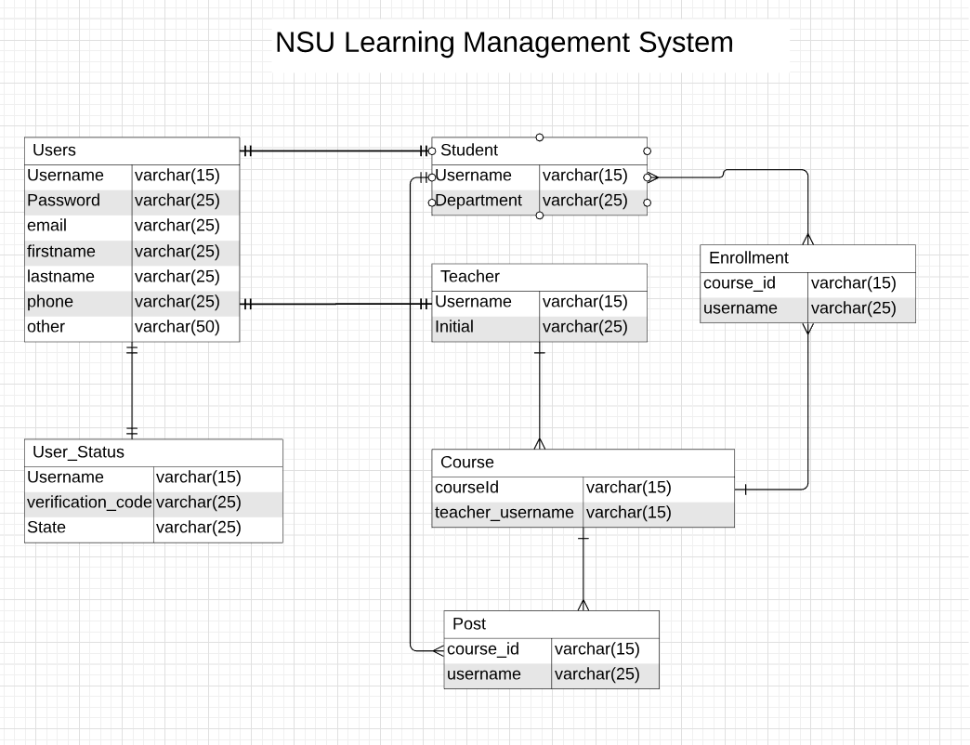

**Fig 1: ER Diagram.**

4

## **Use Case Diagram:**

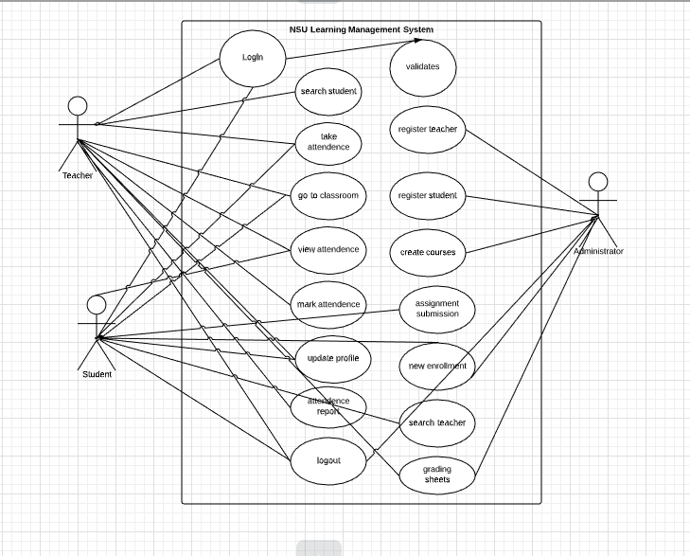

**Fig 2: Use Case Diagram. 5**

6

### **Advantages:**

There are six major advantages of Learning Management Systems: interoperability, accessibility, reusability, durability, maintenance ability and adaptability, which in themselves constitute the concept of Learning Management Systems.

1. Learning Management Systems supports content in various formats: text, video, audio, etc.
2. One can access materials anytime, from everywhere, teachers can modify the content, and students can see the updated material.
3. The evaluation of students is easier and fair, based on student attendance and online quizzes.
4. Students and teachers can re-use the material every time they need.
5. Students can learn collaboratively by setting up a college website with the Learning Management Systems software and helps Keeps organizations up-to-date with compliance regulations. If your organization must stay up-to-date with current compliance regulations, then a Learning Management System can be an invaluable tool.

7

**Conclusion:**

A Learning Management System is a technological tool used to deliver online education and training. An LMS gives clients a way to create and deliver content, organize courses, manage users, and monitor the progress of multiple users, all with relative ease. An LMS may also provide additional advanced features including the ability to manage payments, custom branding, or e-Conferencing. Learning Management Systems are the future of training.

8